car rental system - Insert values
Refer to the given schema diagram. Insert the below records into Rentals Table. Assume the rentals table has been already created.
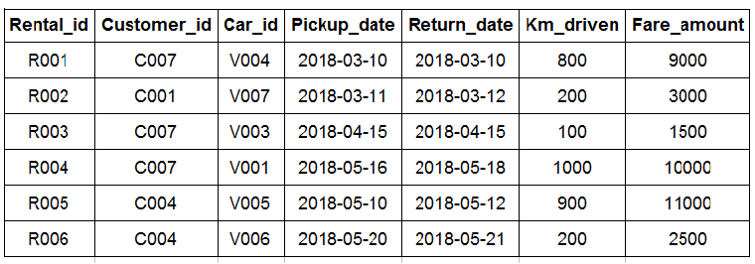
Note: Letters in bold represent the attributes.
NOTE: Maintain the same sequence of column order, as specified in the question description
